Identi cation and spatio-temporal clustering of ash droughts in Sicily

***Utente***

*2025-12-01 10:56:00*

--------------------------------------------

The abstract should be more general: Introduce the problem and where are we working. Then summarize the main results. Generally we should avoid acronymns and references in the abstract. We will revise it at the end :)

***Utente***

*2025-12-01 10:56:53*

--------------------------------------------

"(hereniafter FD, which are "

***Utente***

*2025-12-01 10:59:39*

--------------------------------------------

You can use FD instead of Flash Drought up to now

***Utente***

*2025-12-01 11:01:41*

--------------------------------------------

Before saying what we adopt (that is more from Methodology), I would discuss the methods that are available in literature. Basically what you are referring in the precious sentence

***Utente***

*2025-12-01 11:02:21*

--------------------------------------------

Cite the papers

***Utente***

*2025-12-01 11:02:36*

--------------------------------------------

could be a

November 4, 2025

Abstract

Flash droughts are rapid-onset water de cits that intensify within a few weeks. We present an island-wide characterization for Sicily (2002 2024) using a weekly SPEI at a 1-month scale

|  |  |  |  |  |
| --- | --- | --- | --- | --- |
| computed from water balances *P* | *—* | PET (Hargreaves Samani PET), and a strict, dynamics- | | |
| based detection: a 4-week development phase with ∆SPEI | | | *≤ −*2 culminating at SPEI | *≤ −*1*.*28, |

followed by persistence below this threshold. Station-level detections are aggregated into regional

|  |  |  |  |
| --- | --- | --- | --- |
| episodes with ST-DBSCAN (*εs* | = 40 km, | *εt* | = 7 days, MinPts=7). |

Across 85 SIAS stations, the median ratio ash droughts / short-term droughts reaches 61% (IQR 54 67%), a high value compared with comparable studies. Spatial organization is contrasted: recurrent hotspots appear in the semi-arid western interior and the Palermo Corleone corridor, whereas the north-eastern mountains show a stronger bu ering e ect. Cluster durations are typically close to two weeks, indicating that rapid onset can still coincide with operationally signi cant persistence. Seasonality is bimodal (late spring; late summer autumn) with a relative shift towards autumn after 2013. No robust monotonic correlation is found between the monthly NAO and episode occurrence, although a same-sign winter signal could precondition environments conducive to late-summer rapid intensi cation.

We discuss limitations related to the simple PET choice, the detection thresholds, and hyper- parameter calibration, and outline avenues to strengthen robustness (systematic sensitivity tests, synoptic diagnostics, cross-validation with soil moisture) and to support operational transfer in Mediterranean climates.

# Introduction

Droughts are among the most complex climate extremes to characterize and among the most conse- quential, a ecting water resources, ecosystems, and agriculture worldwide. Recent years have seen increasing attention to ash droughts, rapid-onset water de cits that develop and intensify within a few weeks. Unlike classical seasonal droughts, ash droughts are de ned by their rate of inten- si cation rather than by duration. They arise from interacting de cits in precipitation, elevated evaporative demand, and persistent thermal anomalies, leading to abrupt soil moisture depletion and water stress. Such events challenge early-warning systems because they emerge faster than the monitoring time steps traditionally used by hydrological services. The probabilistic framework for drought characterization was rst laid out by Yev, and later operationalized, for example by the

U.S. Drought Monitor [Svoboda et al.]. Since the synthesis of Otkin et al. [2018], detection has focused on rapid intensi cation. Several metrics have been proposed based on di erent variables soil moisture, evaporative demand, satellite reanalysis. Among these, we adopt the Standardized Precipitation Evapotranspiration Index (SPEI). SPEI is suited to ash-drought studies because it combines precipitation and potential evapotranspiration, can be computed at weekly resolution, and allows inter-site comparison via statistical normalization. SPEI requires estimating potential evapotranspiration (PET); we use the Hargreaves Samani formulation. In practice, the community generally identi es ash drought when three conditions co-occur: a rapid development phase, a de- crease in plant-available water (e.g., soil moisture drawdown), and impacts in social and economic spheres.

The Mediterranean Basin, and Sicily in particular, is a natural laboratory for studying ash droughts.

Owing to its central position in the European Mediterranean and, above all, to anthropogenically forced warming, the Mediterranean is changing faster than many other regions. This warrants heightened vigilance and can shed light on trajectories likely to a ect other regions trending towards aridi cation.

***Utente***

*2025-12-01 11:03:49*

--------------------------------------------

Revise this sentence and expand: Start from the Mediterranean area that is an hotpspot for climate change, then focus on Sicily which lies in its center

***Utente***

*2025-12-01 11:05:43*

--------------------------------------------

delete, just keep the citation

***Utente***

*2025-12-01 11:06:53*

--------------------------------------------

Delete the citation

The island exhibits strong hydroclimatic gradients from semi-arid western plains to humid moun- tain ranges combined with intensive agricultural demand and frequent heatwaves. Despite these vulnerabilities, no comprehensive assessment of ash-drought frequency, seasonality, and spatial or- ganization has been conducted for Sicily from high-resolution observations. Moreover, while several European studies report increases in ash-drought occurrence and shifts in the rainfall calendar af- ter 2010 [Shah et al.,](#_bookmark19) [Noguera et al.](#_bookmark14), [b,](#_bookmark14) [Cammalleri and Toreti], the underlying mechanisms remain poorly understood at regional scale.

Our objectives are fourfold: (1) compute weekly SPEI series for a moderately dense Sicilian network (2002 2024, 1 station*/ ≈* 230 km2) from consistent meteorological inputs; (2) identify ash droughts using a rigorous, rate-of-change de nition; (3) aggregate local detections into regional footprints via ST-DBSCAN; and (4) analyze spatial, seasonal, and large-scale forcings. This approach aims to provide an island-scale characterization of ash droughts in Sicily and to place them within the broader Mediterranean context of climate extremes.

# Methodology

Study area and dataset

The study focuses on Sicily (Italy), the largest island in the Mediterranean Sea, with an area of about 25*,*700 km2. Topography ranges from sea level to over 3,000 m at Mount Etna, with strong variations in elevation and climate. The climate is typically Mediterranean with hot summers (Csa), and strong spatio-temporal variability in precipitation: the annual mean ranges from about 360 mm in the south-east to over 1,300 mm in the north-east, where convective phenomena are more frequent. Rainfall concentrates in winter, while summers are generally dry, though extreme convective episodes can occur.

We use data from SIAS (Servizio Informativo Agrometeorologico Siciliano), which operates about 106 meteorological stations across the island. The dataset includes sub-daily precipitation (10-min step) and air temperature (hourly) series for 2002 2024 (see Fig. 1b d). As sensor-based records, these series may include gaps. To maximize data quality, for each year we retain station-year precipitation and temperature only if *≥* 80% complete (protocol details in Treppiedi et al. [a]). Among the 106 stations, we then retain those with at least 21 years above the 80% completeness threshold. The

nal selection comprises 85 stations used for analysis (see Fig. 1a).

Weekly data are recommended by prior drought studies (e.g., Vicente-Serrano et al.; Noguera et al. [a]), as they better capture rapid changes in atmospheric water demand and surface conditions than coarser monthly steps. Accordingly, all records were aggregated to weekly resolution. Weekly precipitation totals are the sum of 10-min measurements within each week. For air temperature, weekly means were computed separately for Tmin, Tmean, and Tmax by averaging hourly observa- tions over each 7-day window Treppiedi et al. [b]. Aggregation starts on 01/01/2002 at 00:00, using 7-day windows through 21/12/2024 at 00:00.

# SPEI computation

The Standardized Precipitation Evapotranspiration Index (SPEI) is computed following Vicente- Serrano et al., ensuring a statistically robust representation of climatic de cits. For each station, we form the water balance (WB) as weekly precipitation minus weekly potential evapotranspiration (PET) Stagge et al.. Precipitation totals come from aggregation, and PET is estimated. Among PET methods, radiation-based approaches are generally more consistent than Thornthwaite Wang

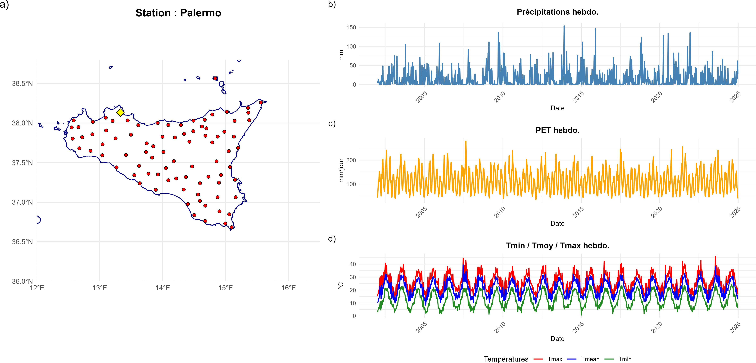

***Utente***

*2025-12-01 11:05:03*

--------------------------------------------

What is hebdo?

***Utente***

*2025-12-01 11:07:33*

--------------------------------------------

which are not available in our dataset.

***Utente***

*2025-12-01 11:08:06*

--------------------------------------------

Analyse

***Utente***

*2025-12-01 11:08:23*

--------------------------------------------

remove it

Figure 1: a) Study area; b) Precipitation series; c) PET; d) Temperature series (Tmin, Tmean, Tmax).

et al.; we therefore use Hargreaves and Samani [1985]:

PET = *Ra ·* 0*.*0023 *·* (*T*mean + 17*.*8) √*T*max *− T*min*,*

where *T*mean is daily mean air temperature ( C), *T*max and *T*min are daily maxima and minima (see Fig. 1c), and *Ra* is daily extraterrestrial radiation at the surface (MJ m*−*2 d*−*1), as provided by the SPEI package Beguer a and Vicente-Serrano [2025]. This choice balances e ciency and accuracy: Penman Monteith is more complete but requires more atmospheric variables and thus additional cost.

# De ning droughts and ash droughts

Several SPEI-based drought classi cations exist McKee et al. [1993], Svoboda et al., Otkin et al.. We distinguish four categories: mild (*−*0*.*5 *>* SPEI *≥ −*0*.*99), moderate (*−*1*.*0 *≥* SPEI *> −*1*.*49), severe (*−*1*.*5 *≥* SPEI *> −*1*.*99), and extreme (SPEI *≤ −*2*.*0) (Wang et al.). As noted by Noguera et al. [a] and Otkin et al. [2018], short accumulation windows (1 3 months) are better suited to identifying rapidly evolving meteorological or agricultural droughts, while longer scales damp abrupt changes. Following Noguera et al. [a], we aggregate the water balance with a 4-week moving window to capture short-term variability relevant to ash-drought dynamics Christian et al. [2019]. The aggregated series are t with a three-parameter log-logistic distribution (scale, shape, location) by maximum likelihood; each value is then transformed to a standard normal index (mean 0, variance 1), i.e., SPEI (Fig. 2a).

We adopt the following criteria, noting that at similar latitudes and climate settings one may expect comparable ash-drought proportions within all short-term droughts (e.g., Spain shows about 40% annually over 60 years under a similar rapid-onset criterion Noguera et al. [a]):

a development phase of at least four consecutive weeks;

a cumulative SPEI decline during this phase *≤ −*2 *z*-units (∆SPEI *≤ −*2);

a nal SPEI value *≤ −*1*.*28 at the end of development;

persistence, with SPEI remaining *≤ −*1*.*28 for at least two additional weeks.

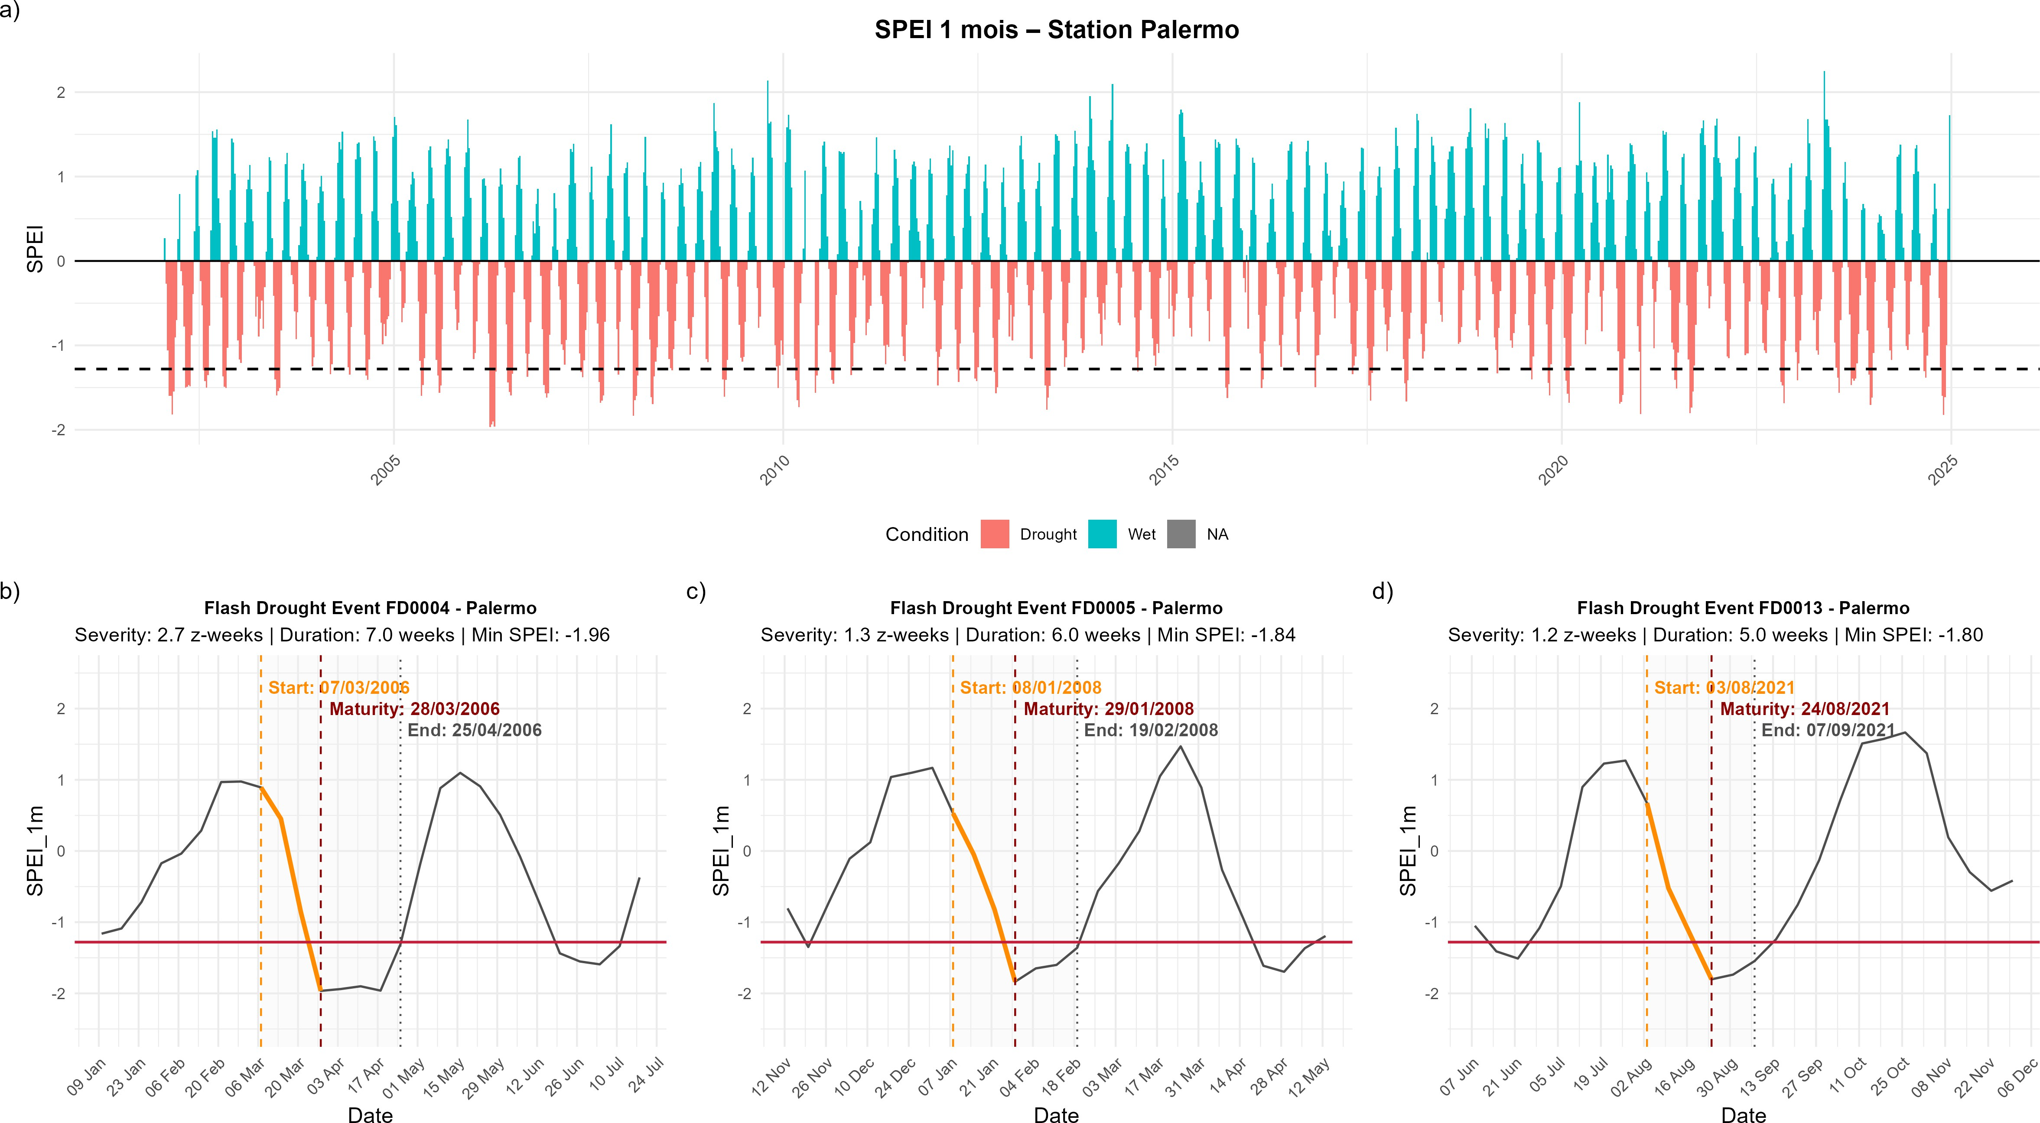

***Utente***

*2025-12-01 11:10:23*

--------------------------------------------

Remove

Figure 2: a) Weekly SPEI (1-month scale) at Palermo; b d) Three most intense ash droughts identi ed at the station.

By construction, SPEI *≤ −*1*.*28 corresponds to the 10th percentile of the standard normal, i.e., severe conditions expected roughly once per decade at a given site under stationarity Noguera et al. [a]. This threshold balances sensitivity (capturing truly damaging events) and speci city (avoiding spurious detections). Conversely, a stricter bound like *−*2*.*0 (*≈* 1st percentile) would isolate only the rarest catastrophic episodes, whereas a looser bound (e.g., *−*1*.*0) would increase false positives. To reduce noise, we also require SPEI to remain *≤ −*1*.*28 for at least two consecutive weekly steps. Case studies and modeling indicate that soil-moisture and evapotranspiration anomalies typically require 10 14 days to translate into measurable agricultural/hydrological impacts; briefer excursions are unlikely to induce major stress ?Otkin et al. [2018]. Finally, the intensity lter is paired with a rapid-onset criterion of ∆SPEI *≤ −*2*.*0 over 4 weeks, retaining only events that combine speed and severity Noguera et al. [a]. Together, these criteria minimize false positives while preserving the ability to capture salient episodes. We track standard metrics (Wang et al., Otkin et al. [2018]): onset date (the date such that, four weeks later, ∆SPEI = *−*2), maturity date (threshold crossing at *−*1*.*28 with su cient decline), end date (return above threshold), duration (consecutive days with SPEI below threshold), and severity, de ned as the sum of SPEI values below the threshold Yevjevich [1983].

Motivation for spatio-temporal clustering. After station-level detection, we seek regional patterns episodes that develop simultaneously in space and time. This requires clustering suited to natural phenomena: ash droughts have irregular boundaries, propagate intermittently, and show heterogeneous intensities across stations. A suitable algorithm should (i) detect clusters without pre- specifying their number, (ii) accept non-convex geometries and variable densities, and (iii) separate isolated detections (noise) from truly connected collective events. Classical partitioning (k-means, k-medoids, hierarchical) relies on global distances and convex shapes, requires xing *k* a priori, and tends to merge disjoint structures or over-segment heterogeneous zones, making it less suitable for hydroclimatic processes with fragmented, irregular footprints.

Density-based methods address these limitations. DBSCAN [Ester et al.,](#_bookmark8) [1996] is a reference: it uses a neighborhood radius *ε* and a minimum points number MinPts. A core point has at least MinPts neighbors within *εs*; border points are close to a core but do not meet the core criterion; other points are labeled noise. Connected core points form a cluster regardless of shape. DBSCAN detects an unknown number of clusters, handles unequal densities, and naturally identi es outliers properties valuable in geosciences [Schubert et al.].

Hydroclimatic phenomena also evolve in time. We therefore use the spatio-temporal extension ST-

DBSCAN [Birant and Kut,](#_bookmark4) [2007], which replaces the 2D neighborhood with a space time cylinder (*εs, εt*): two detections share a neighborhood if their horizontal separation is *< εs* and their time lag is *< εt*. This joint criterion ensures clusters group only events that are both spatially close and quasi-synchronous. For ash droughts where rapidly coalescing local anomalies can yield a regional de cit this constraint is essential: it links stations subjected to a common forcing while avoiding the fusion of independent events separated by several weeks Otkin et al. [2018], ?. ST-DBSCAN thus provides a simple yet robust framework to identify coherent regional footprints, tying statistical density to the physical constraints of spatio-temporal propagation.

***Utente***

*2025-12-01 11:15:22*

--------------------------------------------

This could be merged with the previous one until the definition of the parameters. The should be included into the results

# Tuning ST-DBSCAN hyperparameters

ST-DBSCAN depends on three physical hyperparameters: (i) the spatial tolerance *εs*, (ii) the temporal window *εt*, and (iii) the density threshold MinPts. Their tuning directly conditions the algorithm's ability to distinguish coherent regional events from local or noisy signals.

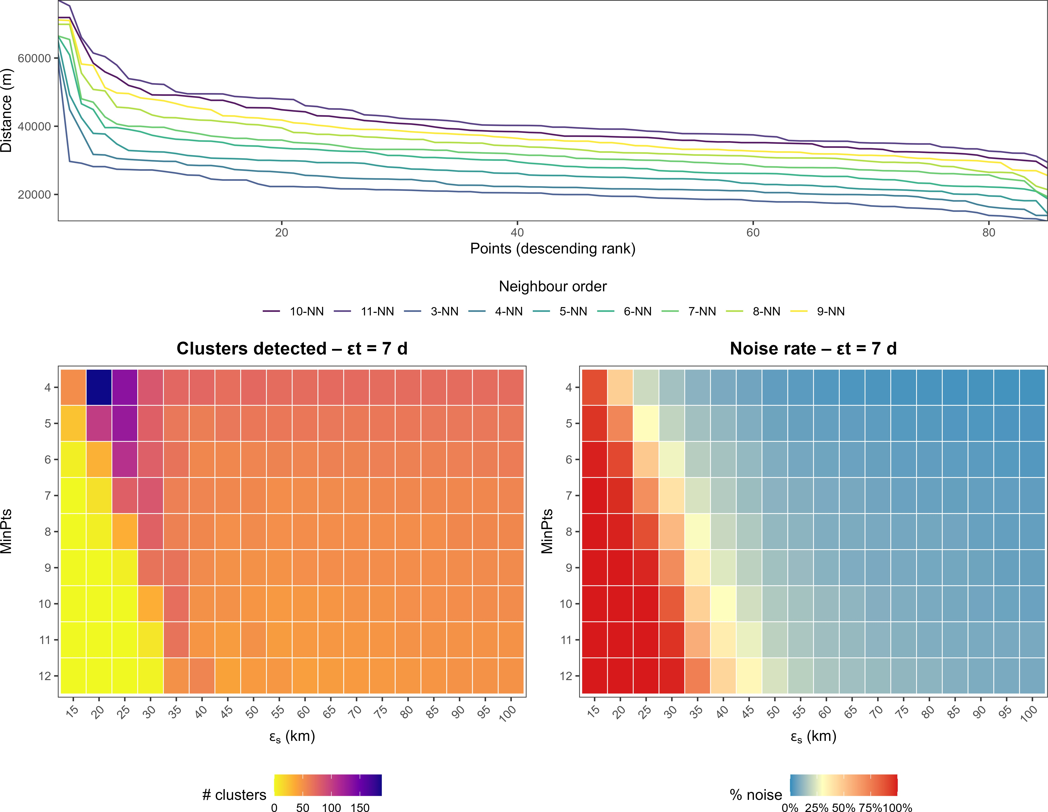

Figure 3: Diagnostics for ST-DBSCAN tuning. (a) *k*-nearest neighbor distance curves (with *k* = MinPts 1); (b) Number of clusters detected for each (*εs,* MinPts) pair; (c) Corresponding noise fraction.

Each hyperparameter re ects a characteristic scale:

1. *εs* is the maximum horizontal distance between stations likely subjected to a common synoptic forcing;
2. *εt* is the maximum time lag for detections to belong to the same rapid-intensi cation pulse;
3. MinPts sets the minimal co-occurrence count for a grouping to qualify as regional rather than local. These parameters are interdependent: values that are too low fragment a single event into micro-clusters, whereas values that are too high fuse independent episodes, diluting spatial contrasts.

Tuning seeks a balance between spatial detail and statistical robustness. We x *εt* = 7 days, consistent with weekly SPEI resolution, then explore a grid of *εs* and MinPts. Two global indicators guide the choice: (i) the number of clusters, which should be su cient to re ect spatial variability; and (ii) the noise fraction (share of unclustered detections), constrained here to *<* 30%, a conven- tional threshold for stable partitioning [Cammalleri and Toreti].

Figure 3 summarizes the key steps:

1. Panel (a) shows the *k*-NN distance curves (*k* = MinPts *−* 1). The rst elbow between 35 and 40 km indicates a natural spatial correlation scale, motivating *εs* = 40 km by the rule of Ester et al. [1996].
2. Panels (b) and (c) show, respectively, the number of clusters and the noise share for each

(*εs,* MinPts). The optimum is around

*εs* = 40 km, MinPts = 7

clusters (*≈* 55) while keeping noise near *≈* 23%.

, which maximizes coherent

We therefore adopt *εs* = 40 km, *εt* = 7 days, and MinPts = 7 for subsequent analyses. Although empirical, this triplet provided the best space time coherence and preserved regional contrasts, ensuring reproducibility and comparability in line with Birant and Kut [2007] and Schubert et al..

***Utente***

*2025-12-01 11:14:07*

--------------------------------------------

I cannot see it from Fig4

***Utente***

*2025-12-01 11:14:24*

--------------------------------------------

Did you define the hydrological years?

***Utente***

*2025-12-01 11:18:33*

--------------------------------------------

We should "smooth" this. We should not just relies on similar latitudes, otherwise the occurence of FD would be a function of the Lat. I would say that we obtain similar results, but the differences might be reconneted to the fact that the climates are similar but not the same, that siciliy is bounded by the see and so the weather mechanisms are different and also that we slightly change the criteria in defyning FD, so we expected differences in the results.

***Utente***

*2025-12-01 11:19:35*

--------------------------------------------

Its meterological FD, so cannot depend on soil characteristics

# Results: detection and characterization of ash droughts

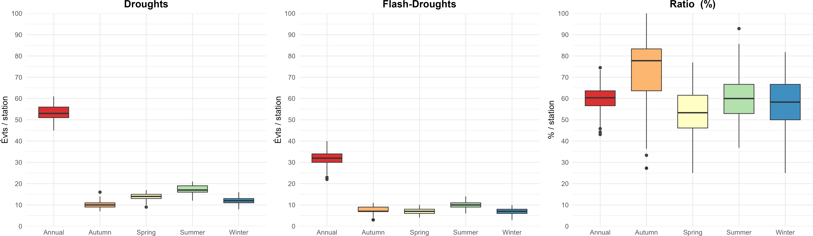

Figure 4: Annual and seasonal frequencies of ash droughts across the 85 SIAS stations.

Over the 22-year period (hydrological years 2002 2024), the SIAS network records 4,551 classical short-term droughts and 2,728 ash droughts at station level. Classical drought counts per station range from 45 to 66 (median 53), while ash droughts range from 22 to 40 (median 32). Expressed as ratios, ash droughts represent 43 75% of all short-term drought occurrences depending on site, with a network median of 61%. Figure 4 summarizes these patterns and highlights three points.

First, seasonality di ers clearly between classes. Classical short-term droughts peak in the Mediter- ranean dry season (July August), whereas ash droughts exhibit a bimodal distribution: a main maximum in early autumn (September October) and a smaller one in late spring. Second, the interquartile range of ash-drought counts is nearly twice that of classical droughts, indicating stronger spatial contrasts. Third, several high-elevation stations in the Nebrodi and Madonie ranges consistently record fewer ash droughts under 30 events over 22 years suggesting an orographic bu ering against rapid soil-moisture depletion.

Compared with other regions where ash-drought climatologies exist, the 61% Sicilian median is exceptionally high. For example, Noguera et al. [b] report about 40% of short-term droughts over

continental Spain (36 43 N) meet a similar rapid-onset criterion, while a global analysis Yuan et al.

shows that even tropical hotspots rarely exceed 30 40%, and midlatitudes (25 50 ) typically lie

near 15 25%.

Recent syntheses for the United States and eastern China likewise place the ash-drought share between 25 and 45% of events [?]. Thus, Sicily not only lies at the upper bound of published values, but exceeds by roughly 20 percentage points what is typically reported at comparable latitudes.

*≈*

37 N) for rapid soil-

This atypical status underscores the central Mediterranean's propensity (

moisture drawdown when intermittent rainfall de cits coincide with elevated vapor-pressure de cits in summer a combination less common in humid temperate latitudes but characteristic of semi-arid Mediterranean climates.

Figure 5 maps the total numbers of classical short-term droughts, ash droughts, and their ratio. A north-east / south-west gradient emerges: Tyrrhenian coastal stations seldom exceed one ash drought per year on average, whereas stations on the semi-arid interior plateau nearly double that frequency. Ratios are particularly high around the Palermo Corleone corridor and the lower Belice valley, agricultural areas with shallow coarse soils and high late-summer vapor-pressure de cits.

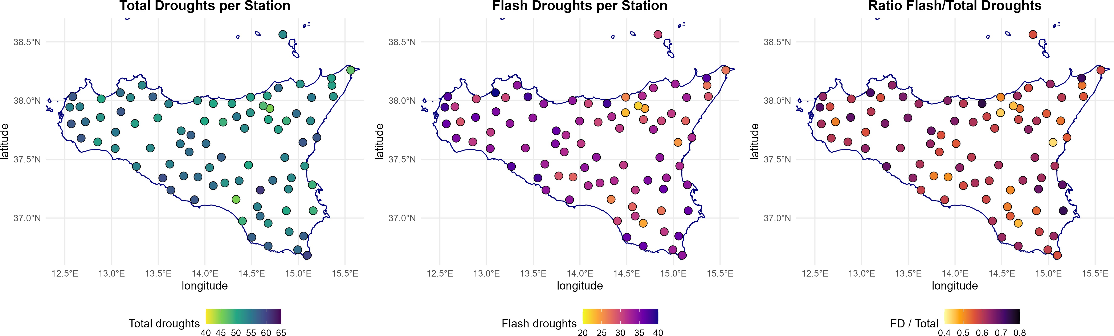

Figure 5: Island-scale maps of the total number of short-term droughts, ash droughts, and their ratio per station over the study period.

Building regional events

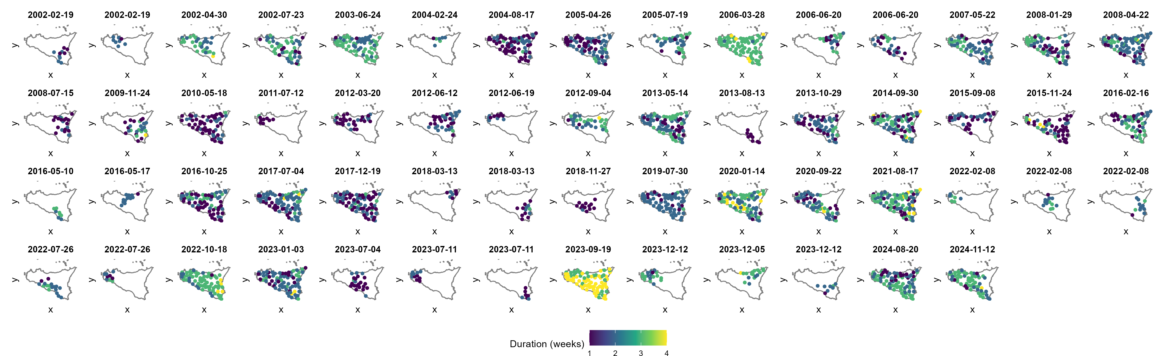

Figure 6: Spatio-temporal clustering of ash droughts using ST-DBSCAN (*ϵs* = 40 km, *ϵt* = 7 days, MinPts = 7). Each panel is a cluster.

Applying ST-DBSCAN to the 2002 2024 catalog (85 stations, weekly resolution) aggregates 2,728 station-week detections into 58 coherent spatio-temporal episodes. No point is rejected as noise, indicating that the density threshold (7 stations within a 40 km 7 d cylinder) already lters purely local anomalies at the detection stage. A typical episode mobilizes on average 40 stations (median 35, range 7 84), nearly half the network, although 37% of clusters remain strictly local (*≤* 20 stations) and about 25% extend to a near island-wide footprint (*≥* 70 stations). The largest event (March 2005) involved 84 stations, virtually the entire network. Cluster duration, de ned as the median interval between onset of SPEI decline and return above the threshold among member stations, averages 1.98 weeks (*≈* 13*.*9 days; IQR 11.1 16.0 d; min max 7 25.7 d), with nearly half (49%) exceeding two weeks: rapid onset ( 4 weeks) can therefore lead to notable persistence. Spatial compactness measured via a density factor (ratio of observed intra-cluster spacing to that expected under a uniform distribution) ranges from 0.30 to 0.53 (mean 0.44, *σ* = 0.09), with only 5% above 0.50; the most compact structures occur mainly in the western lowlands, where short inter-station distances and low SPEI noise favor coherent groupings. A clear hierarchy emerges: 37% local clusters, 38% intermediate regional footprints (21 69 stations), and 25% near island-wide. This distribution re ects coexisting scales: very localized convective events and broader synoptic anomalies that drive extended soil-moisture drawdown, capturing the multi-scale nature of ash-drought organization.

Spatial recurrence of exposure

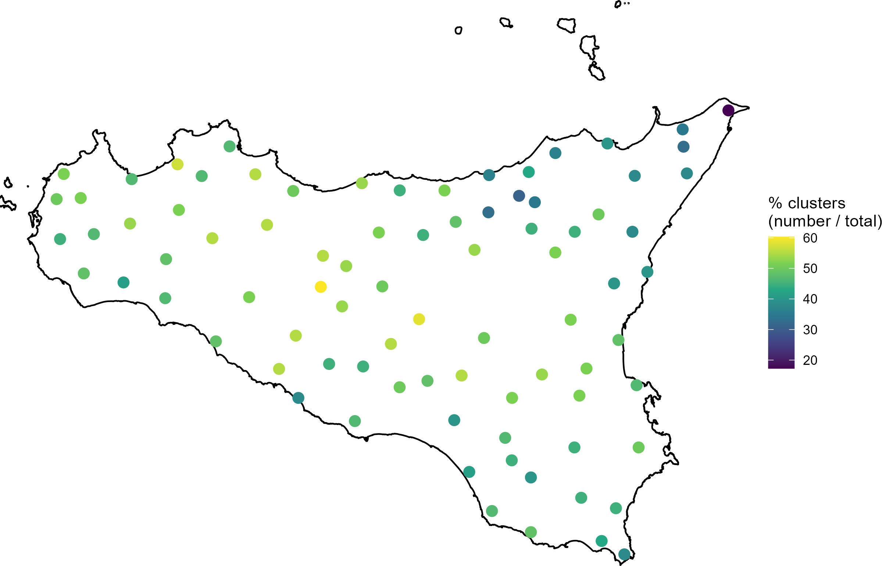

Figure 7: Station-level participation ratio in regional ash-drought clusters (number of clusters involving the station / total number of clusters).

Figure 7 maps, for each of the 85 SIAS stations, the exposure ratio *R*(*s*) = *n*FD(*s*)*/*58, i.e., the proportion of regional ash-drought episodes that station *s* has participated in at least once (con guration: 40 km 7 d, MinPts=7). Values range from 1.7% (one event in 22 years) to 58%, with a median 46.7% and IQR 43.3 51.7%. Over 41% of stations have *R*(*s*) *≥* 50%, implying that, on average, one out of two regional episodes reaches them, whereas only two high-elevation stations remain below 30%. A clear west / north-east contrast appears: the western semi-arid interior and the Palermo Corleone corridor host recurrent rapid-depletion hotspots with ratios often >55%, while the Nebrodi Madonie ridge and north-eastern capes show the lowest values, revealing orographic bu ering. Intermediate ratios (40 50%) characterize the south-eastern carbonate plateau and the southern coast. Together these patterns suggest two regimes: in the west, late anticyclonic blocks and Saharan warm-air intrusions may favor di use synoptic-scale footprints ?; in the north-east, orographic uplift and breeze convergence anchor more con ned mesoscale events [Otkin et al., 2018, Kim et al.]. This reading could be re ned by per-cluster compactness diagnostics (centroid and density factor), linking station-level recurrence to footprint geometry.

Seasonal variability: construction, results, limitations

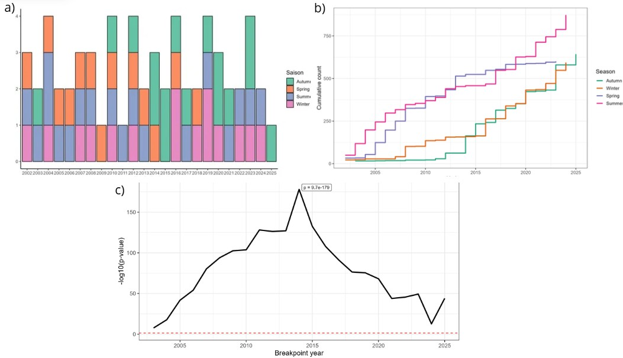

Figure 8: Seasonality of regional episodes: (a) seasonal decomposition by hydrological year; (b) seasonal totals; (c) *χ*2 breakpoint scan on seasonal shares.

To better understand the intra-annual distribution of regional ash droughts, we conduct a sea- sonal analysis to identify periods most prone to onset. Such a season-by-season view is essential in

Mediterranean climates, where the marked succession of rainfall and thermal regimes governs soil recharge and depletion. It links ash-drought dynamics to transitions between wet and dry seasons and to possible shifts in the rainfall calendar over decades.

***Utente***

*2025-12-01 11:23:08*

--------------------------------------------

Lets discuss it better

Each ST-DBSCAN cluster is time-stamped by its onset *t*0 (earliest start among member stations), then assigned to a calendar month and to a hydrological season: winter (December February), spring (March May), summer (June August), and autumn (September November). From the full 2002 2024 series, we count, for each month *m*, the number of regional episodes starting in *m* (*n*clusters(*m*)). These monthly counts are then aggregated by season and hydrological year, to obtain (i) an inter- annual seasonal decomposition and (ii) a series of seasonal totals.

To test whether the distribution across seasons di ers between two periods, we apply a *χ*2 test of independence to a 2 *×* 4 contingency table (periods seasons). The test compares observed sea- sonal frequencies to those expected under stable seasonality. The statistic sums, over all cells, the squared deviations between observed and expected, weighted by the expected frequency; signi cance is assessed against a *χ*2 distribution with 3 degrees of freedom (four seasons minus one sum con- straint). While simple, this approach can detect structural breaks in seasonality without positing a continuous trend. The aggregated distributions (Fig. 8) reveal a bimodal seasonality, with a main maximum in late summer autumn and a smaller one in late spring. This pattern matches typical Mediterranean dynamics: a rst peak during the transition from winter recharge to summer desic- cation, then a second linked to the delayed return of rains [Tramblay and Others,](#_bookmark23) [2013,](#_bookmark23) [Drobinski](#_bookmark7) [and Others,](#_bookmark7) [2016,](#_bookmark7) [Papalexiou and Montanari,](#_bookmark17) [2018,](#_bookmark17) [Toreti and Others,](#_bookmark22) [2019,](#_bookmark22) [Lionello and Others,](#_bookmark11) [2020,](#_bookmark11) [Tramblay and Others,](#_bookmark24) [2020,](#_bookmark24) [Cammalleri and Toreti]. The *χ*2 test on seasonal shares suggests a bend around 2013 2014, marked by a relative increase in autumn occurrences while spring and summer increase more moderately.

This result should be interpreted cautiously. Seasonal counts show serial dependence from year to year, and e ective exposure to clustering (number of valid stations and eligible weeks) varies over time. Moreover, searching for an optimal breakpoint introduces implicit multiplicity, making the exact change point uncertain. We thus retain a coherent signal rather than strict causality: Sicily's

ash-drought seasonality appears bimodal, with a relative shift towards autumn after 2013, consis- tent with regional evidence of a delayed rainfall calendar and lengthening intra-seasonal dry spells. These ndings are best seen as indications of change, not formal proof, but they t a well-documented Mediterranean context.

Large-scale variability and occurrence: focus on the NAO

We explore whether large-scale atmospheric variability modulates the occurrence of regional ash droughts and contributes to changes in their distribution. Speci cally, we test the association be- tween the monthly NAO and the monthly number of detected clusters (a count variable) from 2002 to 2024, using Spearman correlations at several lags (NAO leading by *k* = 0 to 6 months). After multiple-comparison control (Benjamini Hochberg, *α* = 5%), no coe cient is signi cant, which does not support, at this stage, a simple monotonic relationship between the NAO and monthly episode counts. This absence of a direct statistical link does not preclude indirect pathways or conditional e ects: circulation patterns tied to Mediterranean oscillations can favor Saharan warm-air intru- sions into the central basin, strengthening evaporative demand and the propensity for rapid drying ?[Lionello and Others,](#_bookmark11) [2020]. Future work should combine (i) count models (quasi-Poisson or nega- tive binomial) with exposure o sets and season/year e ects, (ii) distributed-lag schemes to capture spread-out responses, and (iii) synoptic diagnostics (Saharan intrusions, geopotential) to explicitly connect large-scale context and regional triggers.

# Conclusion and perspectives

This study o ers a rst regional climatology of ash droughts in Sicily based on a clear, reproducible protocol combining a weekly SPEI at a 1-month scale, a strict dynamic de nition of development

(∆SPEI *≤ −*2 over four weeks with crossing of *−*1*.*28), and spatio-temporal clustering via ST- DBSCAN (*εs* = 40 km, *εt* = 7 days, MinPts = 7). Results indicate that ash droughts constitute a majority share of short-term droughts (median 61%), placing Sicily at the upper bound of values reported for other Mediterranean regions. Spatial organization highlights recurrent hotspots in the semi-arid western interior and the Palermo Corleone corridor, while the north-eastern reliefs exhibit an orographic bu ering e ect. Regional episodes typically last about two weeks, implying that rapid onset can nonetheless yield operationally signi cant persistence. Seasonality is bimodal, with a peak in spring and another in late summer autumn, and appears to shift towards autumn after 2013, consistent with recent literature on a delayed Mediterranean rainfall calendar. No simple monotonic link is found between monthly NAO variability and episode occurrence, although a coherent signal suggests that a positive winter NAO phase could favor conditions conducive to late-summer rapid intensi cation. While robust under the chosen parameter set, these ndings should be interpreted with due caution: the simpli ed Hargreaves Samani PET, empirical detection thresholds, and ST- DBSCAN hyperparameter sensitivity are potential uncertainty sources. Short-term priorities include systematic sensitivity analyses for *εs*, *εt*, MinPts and SPEI thresholds; cross-validation of episodes against independent proxies (soil moisture, energy uxes, vegetation indices, res); and a ner ar- ticulation with Mediterranean synoptic forcings, notably Saharan warm-air intrusions. In the longer term, applying this framework to other Mediterranean basins will test parameter transferability, re-

ne the typology between classical and fast episodes, and strengthen the basis for high-resolution operational ash-drought monitoring. Overall, a simple yet rigorously de ned framework can already yield coherent signals from station observations and opens avenues to better understand rapid water- de cit dynamics in semi-arid Mediterranean regions.

# References

An objective approach to de nitions and investigations of continental hydrologic droughts: Vujica yevjevich: Fort collins, colorado state university, 1967, 19 p. (hydrology paper no. 23). 7(3):353. ISSN 0022-1694. doi: 10.1016/0022-1694(69)90110-3. URL [https://www.sciencedirect.com/](https://www.sciencedirect.com/science/article/pii/0022169469901103) [science/article/pii/0022169469901103](https://www.sciencedirect.com/science/article/pii/0022169469901103).

Santiago Beguer a and Sergio M. Vicente-Serrano. SPEI: Calculation of the Standardized Precipitation-Evapotranspiration Index, 2025. URL [https://CRAN.R-project.org/package=](https://CRAN.R-project.org/package%3DSPEI) [SPEI](https://CRAN.R-project.org/package%3DSPEI). R package version 1.8.1.

Derya Birant and Alp Kut. St-dbscan: An algorithm for clustering spatial temporal data. Data & Knowledge Engineering, 60(1):208 221, 2007. doi: 10.1016/j.datak.2006.01.013.

C. Cammalleri and A. Toreti. A generalized density-based algorithm for the spatiotemporal tracking of drought events. doi: 10.1175/JHM-D-22-0115.1. URL [https://journals.ametsoc.org/view/](https://journals.ametsoc.org/view/journals/hydr/24/3/JHM-D-22-0115.1.xml) [journals/hydr/24/3/JHM-D-22-0115.1.xml](https://journals.ametsoc.org/view/journals/hydr/24/3/JHM-D-22-0115.1.xml). Section: Journal of Hydrometeorology.

Jordan I. Christian, Je rey B. Basara, Jason A. Otkin, Eric D. Hunt, Ryann A. Wake eld, Paul X. Flanagan, and Xiangming Xiao. A methodology for ash drought identi cation: Application of

ash drought frequency across the united states. Journal of Hydrometeorology, 20(5):833 846, 2019. doi: 10.1175/JHM-D-18-0198.1. URL [https://journals.ametsoc.org/view/journals/](https://journals.ametsoc.org/view/journals/hydr/20/5/jhm-d-18-0198_1.xml) [hydr/20/5/jhm-d-18-0198_1.xml](https://journals.ametsoc.org/view/journals/hydr/20/5/jhm-d-18-0198_1.xml).

Philippe Drobinski and Others. Mediterranean heavy precipitation, dry spells and seasonality: mechanisms and recent changes. journal , vol ( no ): pp , 2016. doi: <<doi>>.

Martin Ester, Hans-Peter Kriegel, J rg Sander, and Xiaowei Xu. A density-based algorithm for discovering clusters in large spatial databases with noise. In Proc. 2nd Int. Conf. on Knowledge Discovery and Data Mining (KDD), pages 226 231, 1996.

George H. Hargreaves and Z. A. Samani. Reference crop evapotranspiration from temperature.

Applied Engineering in Agriculture, 1(2):96 99, 1985.

Woon Mi Kim, Santos J. Gonz lez-Roj , and Christoph C. Raible. Extratropical circulation asso- ciated with mediterranean droughts during the last millennium in CMIP5 simulations. 19(12): 2511 2533. ISSN 1814-9324. doi: 10.5194/cp-19-2511-2023. URL [https://cp.copernicus.org/](https://cp.copernicus.org/articles/19/2511/2023/) [articles/19/2511/2023/](https://cp.copernicus.org/articles/19/2511/2023/). Publisher: Copernicus GmbH.

Piero Lionello and Others. The changing mediterranean hydroclimate: trends, variability and ex- tremes. journal , vol ( no ): pp , 2020. doi: <<doi>>.

Thomas B. McKee, Norman J. Doesken, and John Kleist. The relationship of drought frequency and duration to time scales. In Proceedings of the 8th Conference on Applied Climatology, pages 179 183, 1993.

Iv n Noguera, Fernando Dom nguez-Castro, and Sergio M Vicente-Serrano. Characteristics and trends of ash droughts in spain, 1961 2018. 1472(1):155 172, a. Publisher: Wiley Online Library.

Iv n Noguera, Fernando Dom nguez-Castro, and Sergio M. Vicente-Serrano. Flash drought response to precipitation and atmospheric evaporative demand in spain. 12(2):165, b. ISSN 2073-4433. doi: 10.3390/atmos12020165. URL <https://www.mdpi.com/2073-4433/12/2/165>. Number: 2 Publisher: Multidisciplinary Digital Publishing Institute.

Jason A. Otkin, Yafang Zhong, Trent W. Ford, Martha C. Anderson, Christopher Hain, An- drew Hoell, Mark Svoboda, and Hailan Wang. Multivariate evaluation of ash drought across the united states. 60(11):e2024WR037333. ISSN 1944-7973. doi: 10.1029/ 2024WR037333. URL <https://onlinelibrary.wiley.com/doi/abs/10.1029/2024WR037333>.

_eprint: https://agupubs.onlinelibrary.wiley.com/doi/pdf/10.1029/2024WR037333.

Jason A. Otkin, Martin Svoboda, Eric D. Hunt, et al. Flash droughts: A review and assessment of the challenges imposed by rapid-onset droughts in the united states. Bulletin of the American Meteorological Society, 99(6):911 919, 2018. doi: 10.1175/BAMS-D-17-0096.1.

Simon Michael Papalexiou and Alberto Montanari. Global changes in the characteristics of precip- itation: intermittency and extremes. Proceedings of the National Academy of Sciences, 115(49): 12692 12697, 2018. doi: 10.1073/pnas.1804667115.

Erich Schubert, J rg Sander, Martin Ester, Hans Peter Kriegel, and Xiaowei Xu. DBSCAN revisited, revisited: Why and how you should (still) use DBSCAN. 42(3):1 21. ISSN 0362-5915, 1557-4644. doi: 10.1145/3068335. URL <https://dl.acm.org/doi/10.1145/3068335>. Publisher: Association for Computing Machinery (ACM).

Jignesh Shah, Vittal Hari, Oldrich Rakovec, Yannis Markonis, Luis Samaniego, Vimal Mishra, Mar- tin Hanel, Christoph Hinz, and Rohini Kumar. Increasing footprint of climate warming on ash droughts occurrence in europe. 17(6):064017. ISSN 1748-9326. doi: 10.1088/1748-9326/ac6888. URL <https://dx.doi.org/10.1088/1748-9326/ac6888>. Publisher: IOP Publishing.

James H. Stagge, Lena M. Tallaksen, Chong Yu Xu, and Henny A. J. Van Lanen. Standardized precipitation-evapotranspiration index (SPEI) : Sensitivity to potential evapotranspiration model and parameters. volume 363, pages 367 373. ISBN 978-1-907161-41-4. URL [https://library.](https://library.wur.nl/WebQuery/wurpubs/558281) [wur.nl/WebQuery/wurpubs/558281](https://library.wur.nl/WebQuery/wurpubs/558281). ISSN: 0144-7815 Meeting Name: 7th World Flow Regimes from International and Experimental Network Data-Water Conference, FRIEND-Water 2014.

Mark Svoboda, Doug LeComte, Mike Hayes, Richard Heim, Karin Gleason, Jim Angel, Brad Rippey, Rich Tinker, Mike Palecki, David Stooksbury, David Miskus, and Scott Stephens. THE DROUGHT MONITOR. doi: 10.1175/1520-0477-83.8.1181. URL [https://journals.ametsoc.](https://journals.ametsoc.org/view/journals/bams/83/8/1520-0477-83_8_1181.xml) [org/view/journals/bams/83/8/1520-0477-83_8_1181.xml](https://journals.ametsoc.org/view/journals/bams/83/8/1520-0477-83_8_1181.xml). Section: Bulletin of the American Meteorological Society.

Andrea Toreti and Others. Shift and variability of european precipitation timing and persistence.

journal , vol ( no ): pp , 2019. doi: <<doi>>.

David Tramblay and Others. Recent changes in mediterranean rainfall: dry-spell lengthening and seasonal redistribution. journal , vol ( no ): pp , 2013. doi: <<doi>>.

David Tramblay and Others. Future evolution of mediterranean precipitation regime and dry spells.

journal , vol ( no ): pp , 2020. doi: <<doi>>.

D. Treppiedi, G. Cipolla, A. Francipane, and L.v. Noto. Detecting precipitation trend using a multiscale approach based on quantile regression over a mediterranean area. 41(13):5938 5955, a. ISSN 1097-0088. doi: 10.1002/joc.7161. URL [https://onlinelibrary.wiley.com/doi/abs/10.](https://onlinelibrary.wiley.com/doi/abs/10.1002/joc.7161) [1002/joc.7161](https://onlinelibrary.wiley.com/doi/abs/10.1002/joc.7161). _eprint: https://rmets.onlinelibrary.wiley.com/doi/pdf/10.1002/joc.7161.

Dario Treppiedi, Giuseppe Cipolla, Antonio Francipane, Marcella Cannarozzo, and Leonardo Valerio Noto. Investigating the reliability of stationary design rainfall in a mediterranean region under a changing climate. 15(12):2245, b. ISSN 2073-4441. doi: 10.3390/w15122245. URL [https://www.](https://www.mdpi.com/2073-4441/15/12/2245) [mdpi.com/2073-4441/15/12/2245](https://www.mdpi.com/2073-4441/15/12/2245). Number: 12 Publisher: Multidisciplinary Digital Publishing Institute.

Sergio M. Vicente-Serrano, Santiago Beguer a, and Juan I. L pez-Moreno. A multiscalar drought index sensitive to global warming: The standardized precipitation evapotranspiration index. doi: 10.1175/2009JCLI2909.1. URL [https://journals.ametsoc.org/view/journals/clim/23/](https://journals.ametsoc.org/view/journals/clim/23/7/2009jcli2909.1.xml) [7/2009jcli2909.1.xml](https://journals.ametsoc.org/view/journals/clim/23/7/2009jcli2909.1.xml). Section: Journal of Climate.

Qianfeng Wang, Jingyu Zeng, Junyu Qi, Xuesong Zhang, Yue Zeng, Wei Shui, Zhanghua Xu, Ron- grong Zhang, Xiaoping Wu, and Jiang Cong. A multi-scale daily SPEI dataset for drought char- acterization at observation stations over mainland china from 1961 to 2018. 13(2):331 341. ISSN 1866-3508. doi: 10.5194/essd-13-331-2021. URL [https://essd.copernicus.org/articles/13/](https://essd.copernicus.org/articles/13/331/2021/) [331/2021/](https://essd.copernicus.org/articles/13/331/2021/). Publisher: Copernicus GmbH.

Vujica Yevjevich. Probabilistic Approach to Hydrologic Problems. Water Resources Publications, Littleton, Colorado, 1983. Second printing.

Xing Yuan, Yumiao Wang, Peng Ji, Peili Wu, Justin She eld, and Jason A. Otkin. A global tran- sition to ash droughts under climate change. 380(6641):187 191. doi: 10.1126/science.abn6301. URL <https://www.science.org/doi/10.1126/science.abn6301>. Publisher: American Associ- ation for the Advancement of Science.